Experiment No. : 4

Title: Implementation of Static Circular Queue

Batch: B1 Roll No.: 1914078 Experiment No.: 4
Aim: Write a menu driven program to implement a static circular queue using counter method supporting following operations.
1. Create empty queue,
2. Insert an element on the queue,
3. Delete an element from the queue,
4. Display front, rear element or
5. Display all elements of the queue.

__________________________________________________________________________________
Resources Used: Turbo C/ C++/JAVA editor and compiler.
__________________________________________________________________________________
Theory:
Queue -
A queue is an ordered list in which insertion and deletion happens two different ends.
The insertion happens from the rear and the deletion takes place at the front. It works with the FIFO concept i.e. first in first out.
Basic operations of Queue are enqueue, dequeue, isempty, etc.
- Circular Queue : It is a variation of queue in which start of the queue is immediately next of end of the queue.

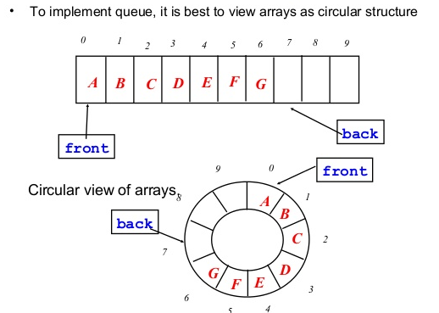
Methods : There are two standard methods to implement a circular queue.

- Method 1 – Counter method – in this we keep a counter to track underflow and overflow of the queue. So one can initialize queue front = 0, rear = 0, and count=0.
- Method 2 – One empty slot between front and rear of the queue – in this we keep front and rear apart by one empty slot, which helps in differentiating between underflow and overflow on circular queue.

______________________________________________________________________________
Algorithm :
- createQueue():
front = 0
rear = 0
count = 0
//Below code is just incase
for (int i = 0; i < maxsize; i++)
arr[i] = NULL
//prints New Queue Created
- void enqueue(typedef val) :

int val //temporary variable
if (count != maxsize)
//prints Enter the value to be added to the queue :
//accepts and stores in temporary variable
arr[rear] = val
rear += 1
rear = rear % maxsize
count += 1
//prints The value has been added to the queue
else
//prints Queue Overflow

- typedef dequeue() :
if (count != 0)
int val = arr[front]
arr[front] = NULL
front += 1
front = front % maxsize
count -= 1
//prints The value that has been dequeued
else
//prints Queue Underflow

- typedef getFront() :
if (count != 0)
prints The value at the front of the queue : arr[front]
else
//prints The queue is empty

- typedef getRear() :
if (count != 0)
//Prints The value at the end of the queue : %d", arr[(rear - 1)]
else
//prints The queue is empty

- void displayAll():
if (count == 0)
//prints The queue is empty
else
//prints The elements in the queue are :
int val = front
if (val <= rear - 1)
while (val < rear)
//prints each value
val++
else
while (val < maxsize)
//prints each value
val++
val = 0
while (val < rear)
//prints each value
val++

- boolean isEmpty() :
return count == 0

6. boolean isFull() :
return count == maxsize
7. int size() :
//prints value of count

Activity: students are expected to implement circular queue using method 1. Make use of circular increment(e.g. front=(front+1)%maxsize)

NOTE : All functions should be able to handle boundary(exceptional) conditions.

#include <stdio.h>
#include <stdlib.h>
#define maxsize 10
int arr[maxsize];
int front, rear, count;

void createQueue();
void Enqueue();
void Dequeue();
void getFront();
void getRear();
void display();
int IsEmpty();
int IsFull();

int main()
{
int ch = 0;
printf("\n======= Circular Queue Implementation =======\n");
while (ch != 10)
{
printf("\n\n1. Create a Queue");
printf("\n2. Enqueue");
printf("\n3. Dequeue");
printf("\n4. Get Front element");
printf("\n5. Get Rear element");
printf("\n6. Display all elements");
printf("\n7. IsEmpty");
printf("\n8. IsFull");
printf("\n9. Number of elements in the queue");
printf("\n10. Exit");
printf("\nEnter your choice from 1-3: ");
scanf("%d", &ch);
switch (ch)
{
case 1:
createQueue();
break;
case 2:
Enqueue();
break;
case 3:
Dequeue();
break;
case 4:
getFront();
break;
case 5:
getRear();
break;
case 6:
display();
break;
case 7:
if (IsEmpty())
printf("\nTrue");
else
{
printf("\nFalse");
}
break;
case 8:
if (IsFull())
printf("\nTrue");
else
{
printf("\nFalse");
}
break;
case 9:
printf("Number of elements in the queue : %d", count);
break;
case 10:
break;
default:
printf("\nEnter your choice from 1-10 only");
break;
}
}
printf("\nThank you");
return 0;
}
void createQueue()
{
front = 0;
rear = 0;
count = 0;
for (int i = 0; i < maxsize; i++)
{
arr[i] = NULL;
}
printf("\nNew Queue Created\n");
}
void Enqueue()
{
int val;
if (count != maxsize)
{
printf("\nEnter the value to be added to the queue : ");
scanf("%d", &val);
arr[rear] = val;
rear += 1;
rear = rear % maxsize;
count += 1;
printf("\nThe value has been added to the queue\n");
}
else
{
printf("\nQueue Overflow");
}
}
void Dequeue()
{
if (count != 0)
{
int val = arr[front];
arr[front] = NULL;
front += 1;
front = front % maxsize;
count -= 1;
printf("\nThe value that has been dequeued : %d\n", val);
}
else
{
printf("\nQueue Underflow");
}
}
void display()
{
if (count == 0)
{
printf("\nQueue is empty");
}
else
{
printf("\nThe elements in the queue are : ");
int val = front;
if (val <= rear - 1)
{
while (val < rear)
{
printf("\n%d", arr[val]);
val++;
}
}
else
{
while (val < maxsize)
{
printf("\n%d", arr[val]);
val++;
}
val = 0;
while (val < rear)
{
printf("\n%d", arr[val]);
val++;
}
}
}
}
void getFront()
{
if (count != 0)
{
printf("\nThe value at the front of the queue : %d", arr[front]);
}
else
{
printf("\nThe queue is empty");
}
}
void getRear()
{
if (count != 0)
{
printf("\nThe value at the end of the queue : %d", arr[(rear - 1)]);
}
else
{
printf("\nThe queue is empty");
}
}
int IsEmpty()
{
return count == 0;
}
int IsFull()
{
return count == maxsize;
}

Output:-

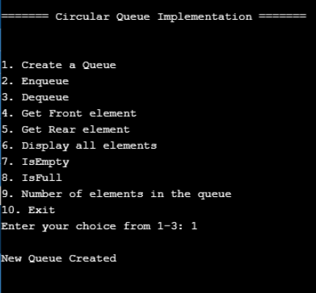
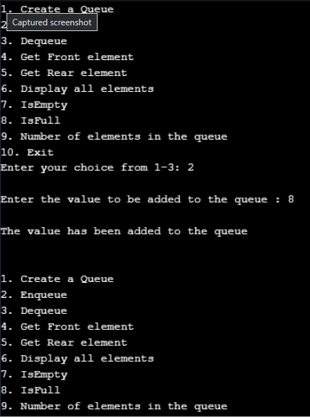
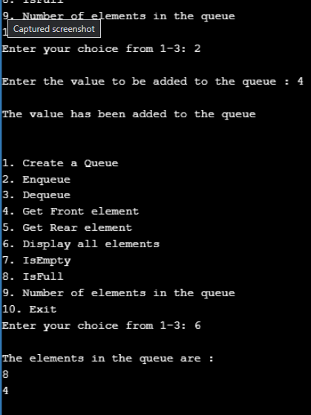
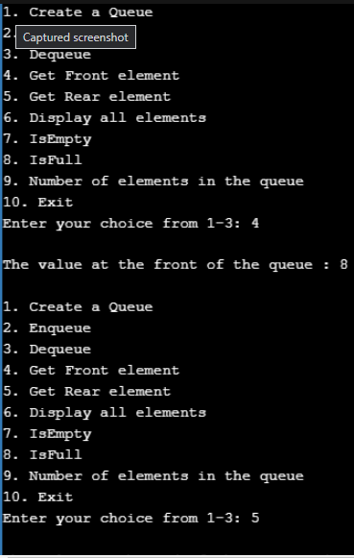
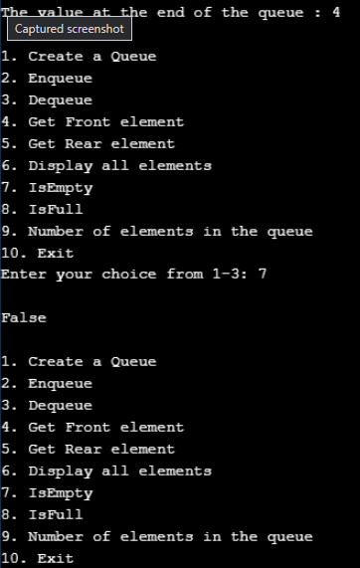
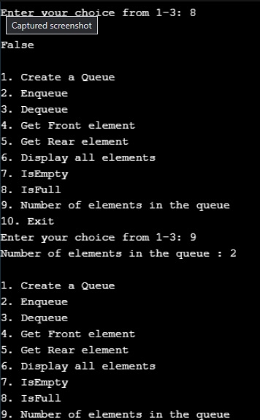
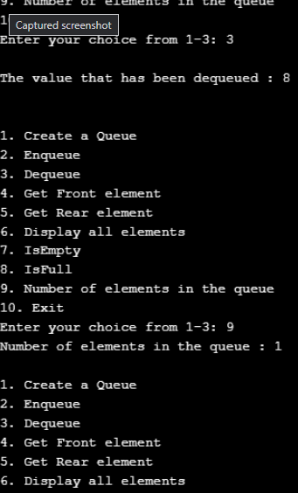
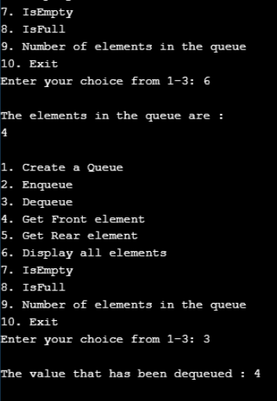
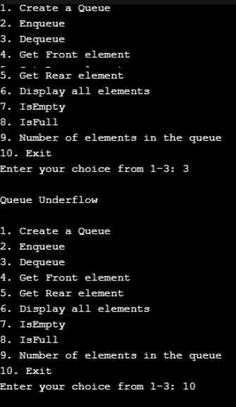
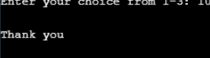
_________________________________________________________________________________
Results: A program implementing counter based solution depicting the correct behaviour of circular queue and capable of handling all possible exceptional conditions and the same is reflecting clearly in the output.
_________________________________________________________________________________
Outcome: Apply linear and non-linear data structure in application development.

Conclusion: We wrote a menu driven program to implement a static circular queue using counter method
.

Grade: AA / AB / BB / BC / CC / CD /DD:
______________________________________________________________________________
Signature of faculty in-charge with date :

References:
Books/ Journals/ Websites:
- Y. Langsam, M. Augenstin and A. Tannenbaum, “Data Structures using C”, Pearson Education Asia, 1st Edition, 2002.

